**Java.MP.C4.M1.MemoryManagement Default Task06**

Изначальный код:

**public class** Main {  
 **public static void** main(String[] args) **throws** InterruptedException, ClassNotFoundException {  
 List<Object> list = **new** ArrayList<Object>();  
 **while**(**true**) {  
 Map<Double, Double> map = **new** HashMap<Double, Double>();  
 map.put(**new** Double(23.12), **new** Double(23.12));  
 map.put(**new** Double(23.11), **new** Double(22.12));  
 map.put(**new** Double(23.10), **new** Double(231.12));  
 map.put(**new** Double(23.9), **new** Double(253.12));  
 map.put(**new** Double(23.8), **new** Double(235.12));  
 map.put(**new** Double(23.7), **new** Double(263.12));  
 map.put(**new** Double(23.6), **new** Double(237.12));  
 map.put(**new** Double(23.52), **new** Double(238.12));  
 Thread.*sleep*(10);  
 list.add(map);  
 }  
 }  
}

Изначально VisualVM:

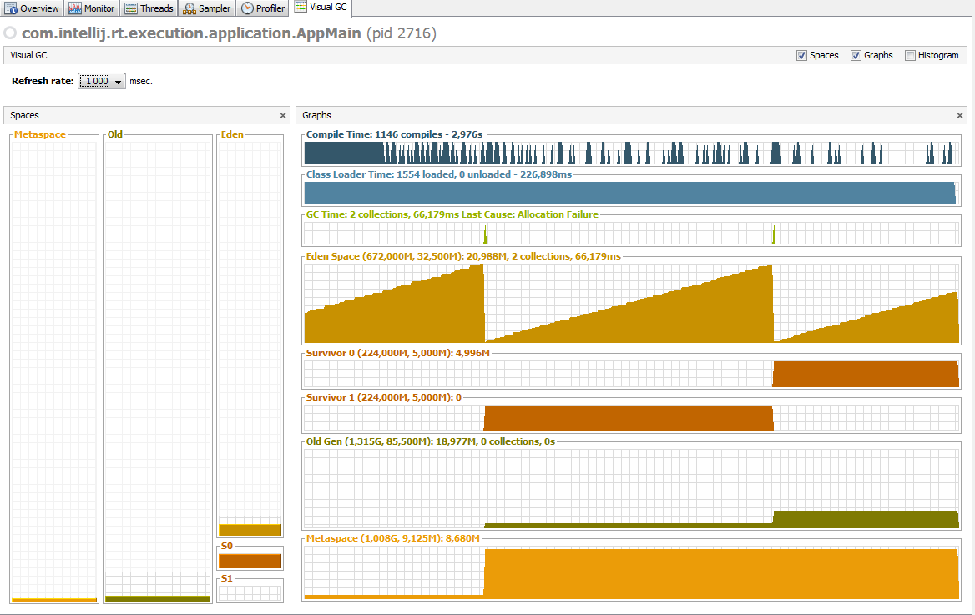

Измененный код:

**public class** Main {  
 **public static void** main(String[] args) **throws** InterruptedException, ClassNotFoundException {  
 List<Object> list = **new** ArrayList<Object>();  
  
 Map<Double, Double> map = **new** HashMap<Double, Double>();  
 map.put(**new** Double(23.12), **new** Double(23.12));  
 map.put(**new** Double(23.11), **new** Double(22.12));  
 map.put(**new** Double(23.10), **new** Double(231.12));  
 map.put(**new** Double(23.9), **new** Double(253.12));  
 map.put(**new** Double(23.8), **new** Double(235.12));  
 map.put(**new** Double(23.7), **new** Double(263.12));  
 map.put(**new** Double(23.6), **new** Double(237.12));  
 map.put(**new** Double(23.52), **new** Double(238.12));  
  
 **while**(**true**) {  
 Thread.*sleep*(10);  
 list.add(map);  
 }  
 }  
}

Измененный VisualVM:

